JAMES COOK UNIVERSITY

COLLEGE OF BUSINESS, LAW AND GOVERNANCE

CP3003 – Web Technologies

Assignment 2 – Web2.0 Project

Jake Dixon, Dane Lennon & Josh Whatmough

Bachelour of information technology and Bachelor of Engineering

WEEK 13 [ MAY 16]

Pong Revised

# Project Objectives

The aim of the project was to reinvent the well known arcade video game Pong. The game is one of the earliest arcade games where each player is presented with a two-dimensional ping-pong-like arena. The main aim is to defeat an opponent in a simulated table-tennis game by earning a higher score. This project aimed to meet these requirements of the game whilst also incorporating additional features and graphics effectively placing a modern twist on the retro game.

## Project Web 2.0 Features

1. Interactivity: Paddles controlled via JavaScript logic and HTML5 Canvas libraries
2. Interoperability with dual players plus spectators: 2 player game and any other clients connected are spectators
3. Using standardized technologies such as html5 and JavaScript: Allow for easy design and implementation and simplicity in the code
4. Modularity and portability: The site can run on many different systems and browsers and can be easily changed or have classes swapped out if need be

## Features Implemented

The completed project was able to implement a working two-dimensional table-tennis arena with multiplayer ability via network connection. The following outlines the extra features that were achieved in the design phase of this project.

1. A two-dimensional table tennis arena
2. Event driven, user controlled paddles via keyboard and mouse input
3. Multiplayer support via network connection
   1. Player 1 hosts, player 2 joins
   2. Server is an intermediate between the two
   3. Server controls what data is sent where to cut down on lag
   4. Spectator mode for a 3rd client to connect to
4. Simulated ball physics implementing table-tennis-like rules
5. Game effects
   1. Performance Penalty: Speed of ball increases with game progress
   2. Comet Tail: Ball has comet tail showing path, the tail increases as the speed increases
6. Scoring system to track game progress
7. Heads Up Display to display messages to the players
8. Power ups
   1. Fast-ball: Speed of ball temporarily increases
   2. Multi-ball: ball divides by 3

# Features Planned but not Implemented

The project phases were successfully completed in accordance with the project plan. However, some features were not implemented due to the time constraint and complexity. These included:

1. Implementation of more power up classes
   1. Paddle length increase
   2. Opponent's paddle length decrease
   3. Weaponised paddle to attack opponent (opponent must avoid while also returning ball)
   4. Paddle Magnetized (ball attracted to paddle)
   5. Take Flight (paddle can be removed from back wall and move in a two-dimensional way)
2. Random events
   1. Earthquake - Screen shake
   2. Stuck-in-the-mud mode (sluggish movements of paddles)
   3. Mind-of-its-own (erratic movements of ball)
3. Round-the-world story mode
   1. Use of themes and borders to portray journey around the world as game progresses
4. Database to store user data.

# Potential Improvements

The project was able to implement a stable version of the Pong Revised game. During the testing phase there were some problems identified which included latency in the network connection and the lack of power-ups during game play. These are identified areas to improve and have been prioritised for future implementations. Version 2.0 of the Pong Revised will include improved latency over the socket.io connection reducing the observed lag for the multiplayer component of the game. This would be achieved by reducing the data packets sent and received across the network connection and implementing a smarter syncing strategy for the multiplayer game play. Future design would also ensure the addition of the features that were planned but not implemented. This includes the power-ups not developed and the around-the-world game play.

# Framework and Technologies Adopted

The design phase of the project included the use of a number of platforms and technologies creating a rich Web2.0 implementation. The Pong Revised game features the use of:

1. Node.js: Executes the socket.io server
2. Apache: to serve the html and JavaScript files, essentially to host the game as a site
3. Socket.io: used for multiplayer connectivity and synchronisation
   1. Server controls the data received and sent from each client
   2. Used to cut down data load between each client
   3. Examples are:
      * Player 1 doesn’t need to receive paddle object from the server
      * The HUD doesn’t need to be sent or received if it hasn’t been updated
      * Controls the client’s “player number” and refreshing of the pages
      * Controls connection and disconnection
4. HTML5 Canvas: use for the two-dimensional graphics and game renderings
5. JavaScript: for the majority of game logic and handling input and output
6. CSS: Basic text styling and custom fonts
7. JSON: easily transferrable objects that are passed between each client
8. Development Software / tools:
   1. Visual Studio Code and other code editors such as brackets
   2. Google Chrome and other web browsers
      1. Developer tools
   3. GitHub: <https://github.com/joshuaWhatmough/alphaPongRevised>
   4. Site: (server may go offline at any time): <http://ditwebtsv.jcu.edu.au/~jc259368/pong>

# Team Review on Individual Contributions of Each Member

|  |  |  |  |  |
| --- | --- | --- | --- | --- |
| **Member** | **Leadership** | **Technical Contributions** | **Skill Contributions** | **Overall** |
| **Jake Dixon** | ⅓ | ½ | ⅓ | 40/100 |
| **Dane Lennon** | ⅓ | ¼ | ⅓ | 30/100 |
| **Joshua Whatmough** | ⅓ | ¼ | ⅓ | 30/100 |

# 

# Actual Implementation Schedule

Initially, the project requirements outlined a design that involved condensing the code into a single file. However, throughout the design cycles, this method proved difficult to read. It also increased the complexity required to debug and refactor. The implementation was then shifted to an Object Oriented Programming (OOP) design structure. Each element within the game was designed to have its own class ensuring abstraction and proper development methods. OOP design made it easier to implement new features and swap out classes if a better one is written.

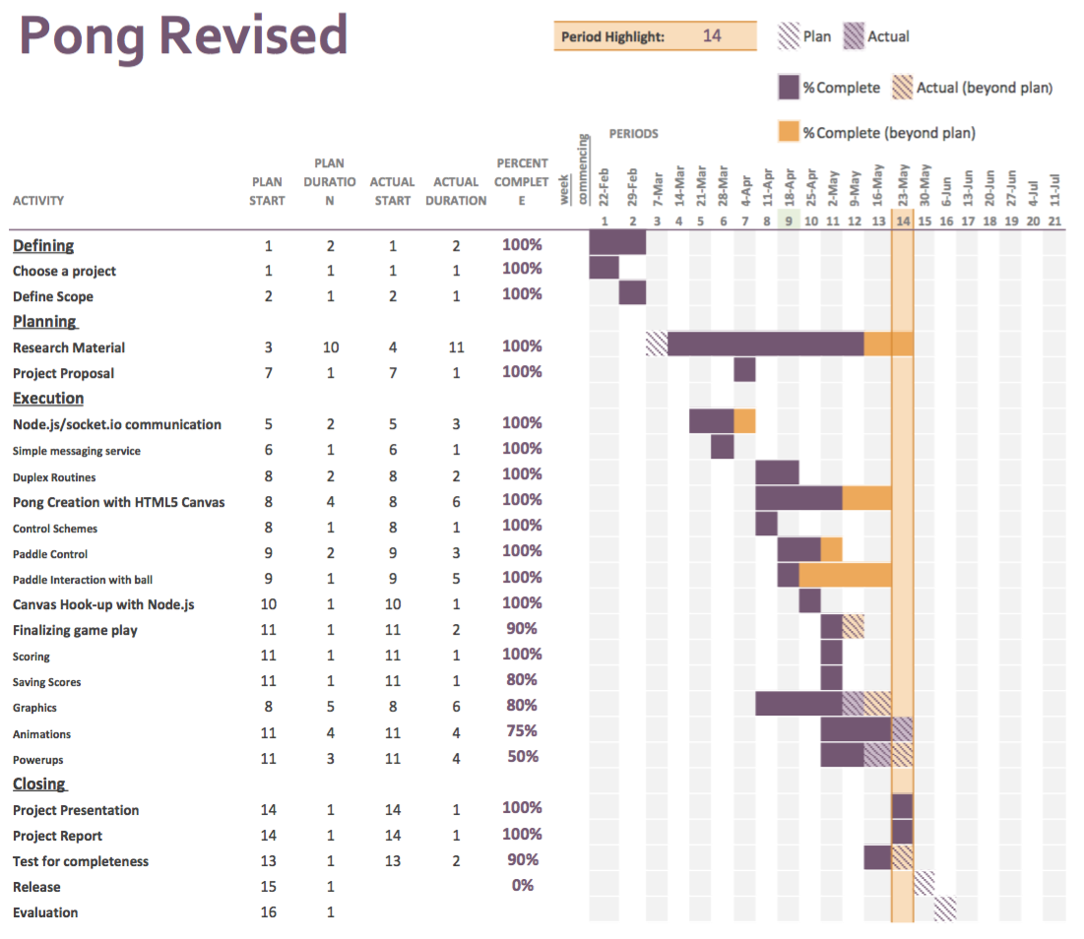

Figure 1 - Project Timeline

# Project Setup Instructions

1. The game uses a server to host HTML to each client
2. Server setup:
   1. Server needs to have web hosting capabilities
   2. Server needs to have node.js installed
   3. The server was configured to host the game html and JavaScript files to each client
   4. The server also executed the node.js server.js file which is routed through a port to the clients
   5. The server awaits incoming connections
3. Client setup:
   1. So long as the server is configured correctly, a client should be able to connect to the server via it’s IP or domain name and commence playing the game with another person
   2. Server configuration for localhost
      1. In the game.js file configure the line socket variable so that it points to the server’s IP address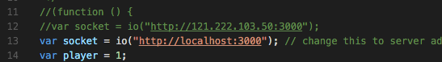
      2. In this case the server is the localhost and the port is 3000
      3. In the index.js file set the port to 3000Screen Shot 2016-05-23 at 10.59.31 PM.png
      4. Execute the NodeJS server with the command “node index.js”
      5. Wait till the output shows that the server is listening to the port
      6. Open the index.html file and the server output should show that you have connected.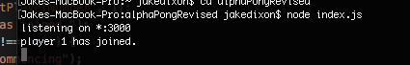
4. Server configuration for outside server (may not work the same for everyone)
   1. Make sure that the game files are in a directory that is hosted from the server, for example the public/www directory
   2. Edit the game.js file so that the socket variable points to the external IP of the server
   3. Forward the port 3000 through your router
   4. Execute the node.js server
   5. Type the server’s external IP into a browser and it should load

# Appendix A - Reflective Journal

|  |  |  |  |
| --- | --- | --- | --- |
| **Date** | **Git Commit Message** | **By** | **Remarks** |
| 7 Apr 16 | Initial Commit | Joshua Whatmough | Project commenced |
| 8 Apr 16 | Add functionality to ensure paddle does not draw off screen | Dane Lennon | Observed paddles sliding out of bounds |
| 10 Apr 16 | Add mouse paddle control | Dane Lennon | Mouse events used. Keyboard control was superseded |
| 10 Apr 16 | Add socket.io dependencies and the chat prototype files for references | Jake Dixon | Basic server app and connectivity between two clients. Chat prototype for reference |
| 10 Apr 16 | Integrate CSS into html  Add socket.io server script index.js  Add socket.io client script | Jake Dixon | Implemented logic to parse the html. |
| 12 Apr 16 | Latency Test | Jake Dixon | Testing the latency |
| 12 Apr 16 | Add maths for determining where on the paddle the ball hit | Dane Lennon | Paddle divided into 3 sections |
| 12 Apr 16 | Hit detection on 2nd paddle | Joshua Whatmough | Player 2 paddle hit detection logic implemented |
| 13 Apr 16 | Add basic 2p play | Jake Dixon | Passing paddle data between two clients so that each can move a paddle |
| 13 Apr 16 | Add Paddle.js | Dane Lennon | Commenced separation of class files |
| 26 Apr 16 | Ball class completed | Jake Dixon | Separated game into classes for OOP |
| 27 Apr 16 | Add documentation to the ball class | Dane Lennon | Documented using JSDoc |
| 27 Apr 16 | Ball bouncing off paddles and hit detections | Jake Dixon | Modifications to the way the ball is deflected |
| 27 Apr 16 | Amend hitTest Parameters to ensure paddle  does not rely on knowing about ball class | Dane Lennon | Instead of ball object passed to paddle hitTest, the ball x and y coordinates were passed to paddle |
| 27 Apr 16 | making some OOP | Jake Dixon | Adding some more separate classes |
| 27 Apr 16 | multi ball! | Dane Lennon | Multi-ball functionality commenced |
| 27 Apr 16 | Adjust paddle height limitations | Joshua Whatmough | Ensure paddle can reach sides of game arena |
| 27 Apr 16 | Made the number of balls modular | Jake Dixon | Added some parameters to support power ups |
| 27 Apr 16 | Major additions for server side: 2p paddles, server side backend for ball and paddle control | Jake Dixon | Halved the number of requests to the server for the ball passing and reduced the paddle data by 90% |
| 27 Apr 16 | Start p2 hitTest | Jake Dixon | Re-implementing the 2nd paddles hit testing |
| 28 Apr 16 | 2nd paddle hitTest now works | Jake Dixon | Fixed a few bugs belonging to the hit detection |
| 28 Apr 16 | Add player detection for connecting / disconnecting | Jake Dixon | add a wait for 2nd player to join, add a disconnection listener so the game stops if p1 or 2 disconnect, add hit detection on p2 paddle (needs working on), add spectator mode |
| 29 Apr 16 | Add scoreboard / HUD | Jake Dixon | Basic implementation for keeping score and displaying messages |
| 03 May 16 | small aesthetic updates and documentation | Jake Dixon | Added a custom font and changed some colours. |
| 03 May 16 | Add ball comet tail | Jake Dixon | Implemented a tail that follows the comet. Basically just an array of the previous 10 positions |
| 04 May 16 | add calcInitialVelocity function and add testBall.html file | Dane Lennon | Fixed the initial position and direction of the balls |
| 04 May 16 | Fixed hitTest2 function | Joshua Whatmough | Tweaking the p2 paddle hit test again |
| 04 May 16 | add getHitPosition function for paddle 1 | Dane Lennon | getHitPosition function created for reuse |
| 04 May 16 | Started a PowerUp Class and multiball extension, | Joshua Whatmough | Also added a factory class for powerUp generation |
| 04 May 16 | Move powerup classes to their own folder | Joshua Whatmough | This was done to help reduce clutter |
| 04 May 16 | Halved the data going to server | Jake Dixon | Once again improved the server code so now each player only received the data it needs |
| 04 May 16 | server side optimizations for paddles | Jake Dixon | P1 doesn’t need to know about p1’s paddle from server |
| 11 May 16 | added muitiball support code | Jake Dixon | Observation made that more than 10 balls across server will cause lag |
| 11 May 16 | rewrote server connection | Jake Dixon | Complete rewrite of the way each client connects to the server. Stores session ids and can handle page refreshes now |
| 18 May 16 | power up class move now works | Joshua Whatmough | Power up now bounces from top to bottom |
| 18 May 16 | fastball.js added | Joshua Whatmough | Initial file skeleton for the power up |
| 23 May 16 | fix paddle bounce and resolve hitTest functions into single function | Dane Lennon | hitTest for both functions resolved into single function |
| 22 May 16 | started work on implementing powers | Jake Dixon | Got the power up to draw on the screen |
| 24 May 16 | Hittest for multiball, and multiball functionality working. | Joshua Whatmough | Ball can now hit the power up |
| 24 May 16 | MultiBalls now spawns on power up, rather than in the centre | Joshua Whatmough | Fixed the positions that the balls spawn when hitting a multiball |
| 24 May 16 | Fix ball respawn | Jake Dixon | Ball was going off screen and not respawning |
| 24 May 16 | fix scoring of MB and paddle bounce speeds in y direction | Dane Lennon | Ball now bounces faster in y direction for upper and lower parts of paddle |
| 25 May 16 | Fix MB spawning | Jake Dixon | Multiball now passed over the server so both clients support it |
| 26 May 16 | Add Fastball | Joshua Whatmough | The effect of making the ball fast is now implemented |